Prelab 6

Shiyu Wang

Pre 6.1)

1. What is the functionality of “enb” of the counter?

Enb is available only when we select count enable port. It is an operation of counter which accept Boolean as input and add one stack each time when input is 1. And it does nothing when input is 0. (Maximum of the word length is set in HDL Counter, in the example, we used 8 bits, which is 255). Therefore, the counter restores to 0 after 255 times.

1. Include in your report a print of the Simulink design, and representative scope outputs.

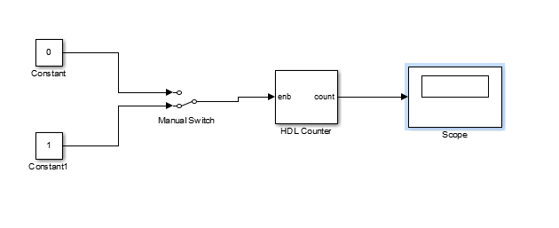

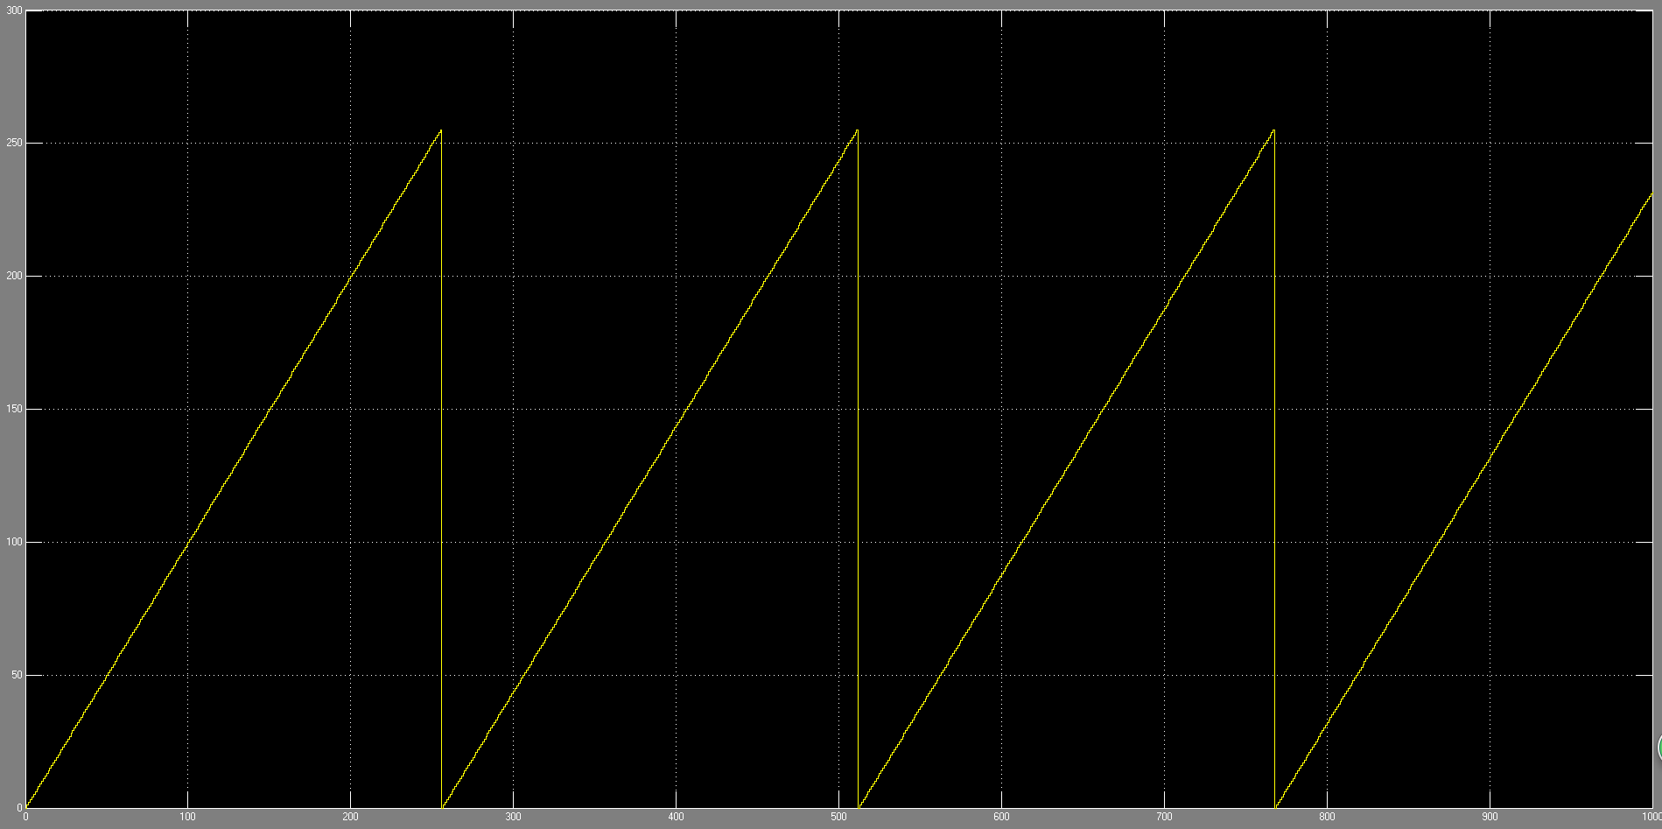

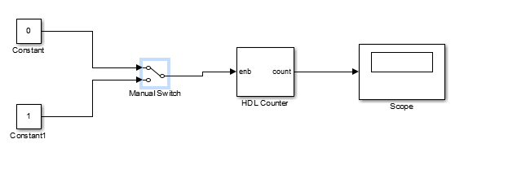

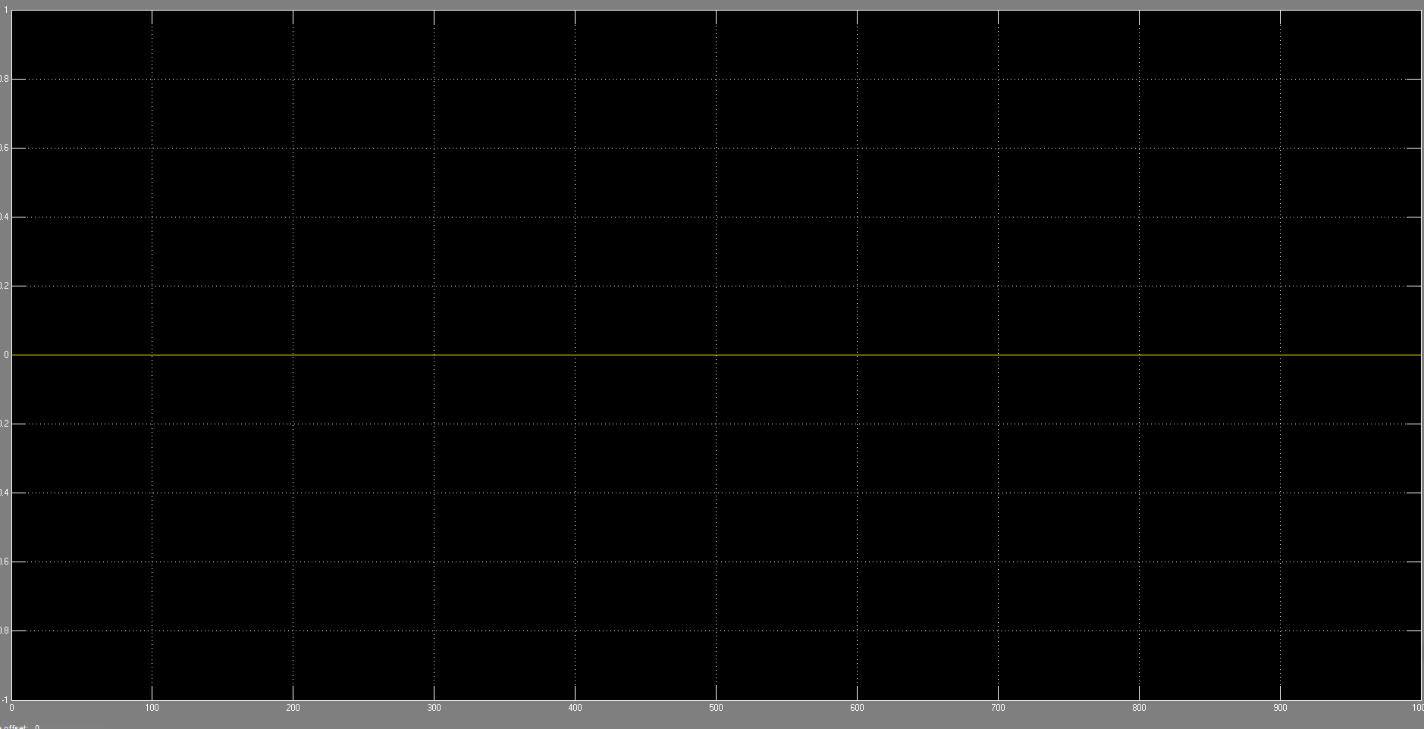

Pre 6.2)

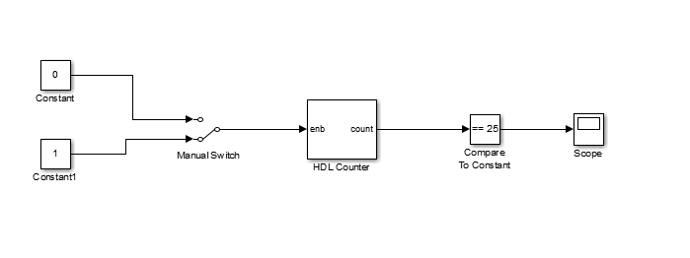

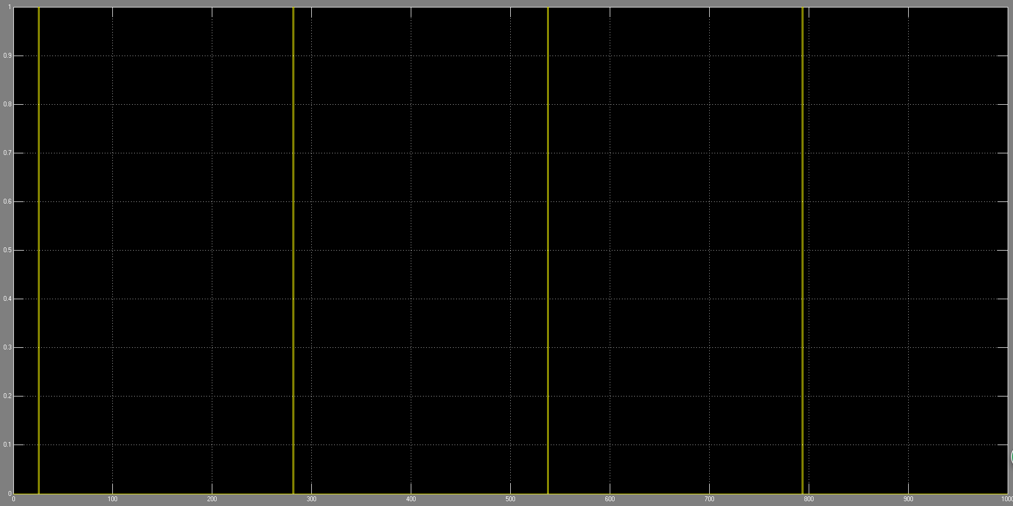

The scope will show 1 when the counter gets 25 stacks. Because our word length is 8, so it will show 1 at 25, 25+256, 255 + 256 *2, etc.

Pre 6.3)

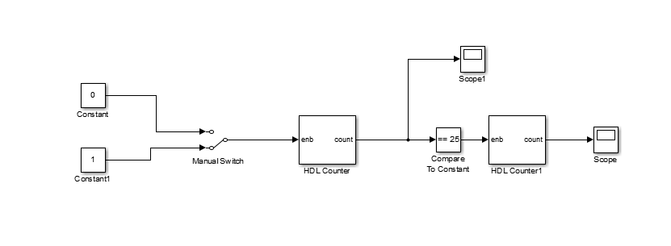

According to the Scopes, the scope1 work the same way as it was in counter_simple to count from 0 to 255 over and over. And the cascaded scope will show how many 25 do we get. Each time when scope1 shows 25, it will add 1 to the scope, so it is actually a counter of counter.

Pre 6.4)

To increase or decrease the counting speed of the second counter, we can modify the comparator. Because the second counter is used to count the truth of the comparator. If we make it >= 25, it will be increased so much higher. On the other hand if we modify the word length, the speed also will change because it will change the appearance of comparator returning truth. Also, the number of test cycle will change the speed.